Testimony of Mike Sloan
Managing Consultant
The Wind Coalition

before the House Select Committee on
Energy Independence and Global Warming
Hearing on "Renewable Electricity Standards: Lighting the Way"

September 20, 2007

My name is Mike Sloan, Managing Consultant of The Wind Coalition ("Coalition"). I am appearing today to provide information about how a Renewable Electricity Standard (RES) and related development policies have fostered a robust wind industry in Texas. The Wind Coalition is an association of 25 companies, trade associations, and environmental and consumer groups that promote the use of the abundant wind energy resources of the South Central United States in Texas, Oklahoma, Kansas, New Mexico, Arkansas, Missouri and Louisiana.

Overview

Wind power is a cost-effective and readily available technology for zero emission and zero water consumption electricity generation, capable of being added rapidly to contribute meaningfully to state and national electric needs. Wind power is broadly recognized as among the most important near-term elements of the climate solution. The Texas experience offers several observations applicable to consideration of a national RES:
1) Wind power is ready to play a significant role in meeting America’s energy needs;
2) Stable policy support is essential for renewable energy to succeed;

3) Transmission infrastructure can and must be built to meet State or Federal RES.

The success of the Texas wind industry is a leading example of how government leadership combined with well-conceived policies can effectively catalyze clean energy development. This wind power success story is even more remarkable coming from Texas, which is not traditionally considered among the vanguard of environmental policy.

Status of Wind Power – A Significant Texas Energy Industry

Prior to November 1995 – less than twelve years ago – there were no commercial wind projects operating in Texas. At that time, Texas used less renewable energy on a percentage basis than any other state in the nation. A focused effort by Texas policy-makers to stimulate renewable energy development through a RES has proven very effective. During 2006, Texas passed California to become the nation's #1 producer of wind energy. Bolstered by a proactive transmission policy that will ensure transmission infrastructure is developed to the state's best renewable resource areas – a policy known as "Competitive Renewable Energy Zones" (CREZ) – interest in Texas wind development has skyrocketed. During 2007, Texas is expected to add approximately 2,000 MW of wind capacity – an investment of more than $3 billion – that represents more than half of anticipated wind power installations in the U.S. for the year.

In a measure of current interest in wind power, information from the Electric Reliability Council of Texas (ERCOT; the grid operator for the majority of Texas) suggests capacity additions of wind power will exceed the combined capacity additions of all other types of power plants (coal, gas, nuclear, etc.) during 2006 and again in 2007.

In a measure of future interest in wind power, as measured by ERCOT's total generation interconnection request activity, there is presently greater investor interest in building new wind power facilities than in building any other type of power plant. In-service wind plus all wind generation interconnection activity in Texas total more than 40,000 MW.

Clearly, wind power is not awaiting a technology breakthrough. Based on current incentives and regulations prevailing in the energy sector, wind power is competitive today in many states and can be developed quickly relative to other types of power plants. Wind power is ready to play a significant role in meeting America’s energy needs.

Texas Wind Industry Vital Statistics
(Based on ERCOT data for 9/15/07; Southwest Power Pool (SPP) data for 8/15/07)

Wind Power Now "In-Service" Statewide: 4,525 MW (includes not yet complete projects under construction that are delivering power to the grid today).

New Interconnection Agreements for Wind Power (most of these projects are likely to go into service during the next year or two).
ERCOT Grid (serves most of Texas): 2,629 MW
SPP Grid (Texas Panhandle): 1,045 MW (720 MW of which are
suspended due to a lack of transmission and access to buyers)

Wind Interconnection Requests for 2007- 2010: (only a modest fraction of these current totals are likely to be installed, due in part to transmission shortages)
ERCOT Grid: 26,897 MW Wind (all non-wind = 21,316 MW)
SPP Grid: 4,496 MW Wind

CREZ Transmission: The Public Utility Commission of Texas is expected to designate 8 areas as wind zones (CREZ) and authorize transmission plans sufficient to support aggregate wind capacity within Texas of at least 10,000 MW up to approximately 26,000 MW.

For reference, Texas' Peak Electric Load is approximately 72,000 MW and growing, motivating a need for a variety of new power plants.
Stable Policy Support helped foster Texas' Robust Wind Industry

Texas has achieved success with wind power through a package of effective state policies that complement available federal policies in delivering significant results. These policies include: 1) Education through Deliberative Polls 2) An effective market catalyst through a Renewable Electricity Standard (RES), 3) Renewable Energy Credits (REC), 4) Competitive Renewable Energy Zones (CREZ), 5) Appropriate producer incentives such as the federal Production Tax Credit (PTC) and state property tax abatements. Texas' success is a credit to visionary state policy makers and regulators and the broad cooperation of consumer, environmental and energy industry stakeholders.

1) Education: Texas Deliberative PollsTM, 1996-1998. These utility-conducted polls showed Texas electric customers overwhelmingly wanted cleaner energy resources. The poll results were helpful to Texas legislators, utilities and other stakeholders in developing support for a RES mechanism requiring a minimum level of renewable energy use.

Utility Customer Deliberative Poll Results for 8 Utilities in Texas
First Choice Preference among residential customers (assuming cost is same)
49% prefer Renewables (Solar, Wind, Biomass)
31% prefer Reduce Need (Energy Efficiency)
14% prefer Fossil (Gas, Coal)
5% prefer Buy & Transport from others

2) Effective Market Catalyst: Renewable Energy Standard (RES), 1999 & 2005. Texas goal for renewable energy is a leading example of a Renewable Electricity Standard that: (a) promotes the use of renewable energy (b) Sets minimum levels of renewable energy use for sellers of electricity and (c) established penalties for insufficient use of renewables. The RES has proven to be an exceptional catalyst, going from legislative concept to $1 billion worth of on-the-ground renewable energy production facilities in less than 3 years. The early success of the program led to an expansion of the RES in 2005.

February 1999 – RES is legislative concept
May 1999 – Texas legislature passed SB7, which included RES
December 1999 – RES implementation rules completed
January 2000 – utilities begin solicitations for renewable energy
December 2001 – 912 MW of new wind projects in service in Texas.

3) Flexible Mechanism to Stimulate Voluntary Market: Renewable Energy Credits. The currency for authenticating compliance with the RES is Renewable Energy Credits (RECs), which represent 1 Megawatt-hour of generation from a qualified renewable energy generator. RECs have become a convenient and accepted method of validating voluntary purchases of renewable energy as well. Voluntary renewable energy markets drive additional demand beyond the Texas RES and have resulted in Texas becoming a leader in voluntary green power sales.

4) Ensure Transmission Infrastructure: Competitive Renewable Energy Zones. CREZ is a proactive policy to provide transmission to the best renewable energy areas, playing an essential role in facilitating the renewable energy market. The basic steps of any proactive transmission development process are:

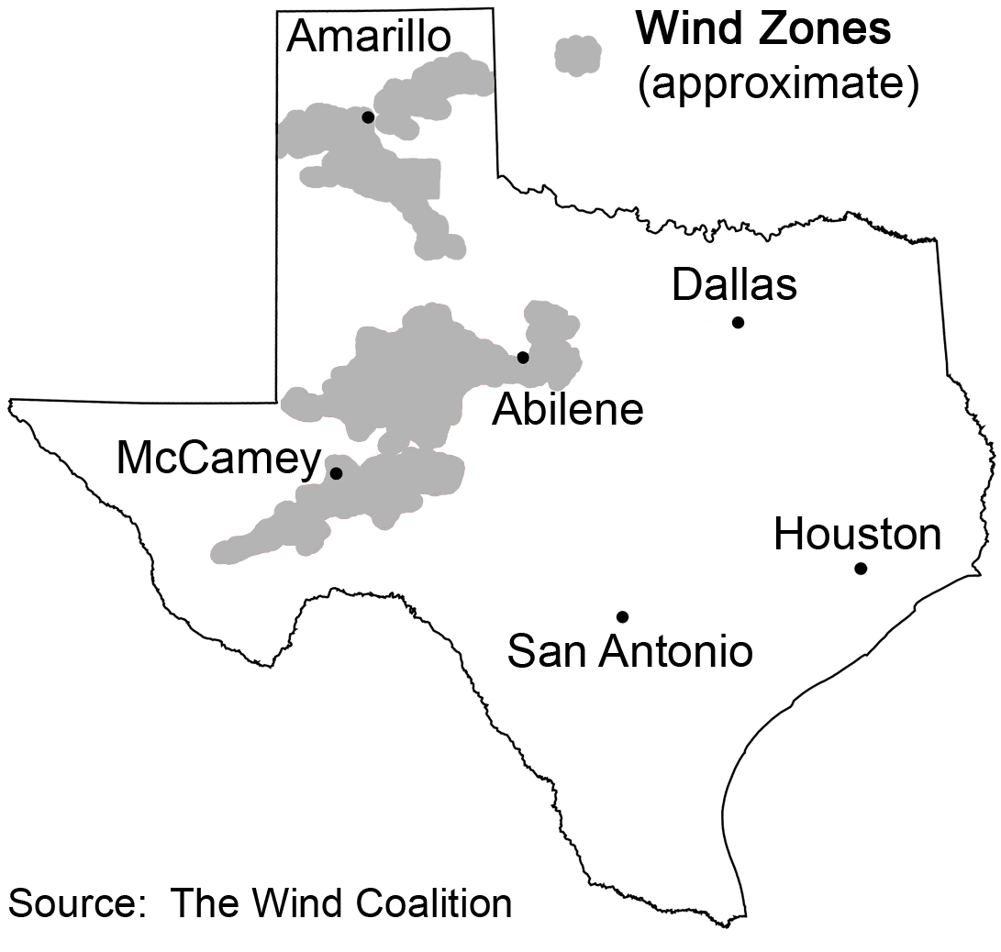
1) Identify the Best Resource Zones

2) Develop a Transmission Master Plan

3) Begin Building Transmission to Zones

The Public Utility Commission of Texas (PUCT) is in the midst of a contested case to establish CREZ. An interim final order is due this week. A map identifying the approximate areas that have been verbally designated by the PUCT as CREZ are identified in the map. Additional analyses are now underway to optimize transmission plans to accomodate wind power from these CREZ at levels between 10,000 MW up to approximately 26,000 MW and to evaluate integrating high levels of wind power into the ERCOT system. A final decision on CREZ and specific transmission lines is expected approximately March 2008.

5) Incentives: Federal Production Tax Credit (PTC) and State Property Taxes

Wind power has higher up-front costs than most conventional power plant alternatives, thus presenting a higher hurdle for investors to justify. Prudent incentives to promote investment in new technologies are often needed, and in the case of Texas, such incentives have proven effective.

The Federal Production Tax Credit (PTC) has played a critical role in the effectiveness of the Texas RES. Examination of the history of Texas' wind development indicate an extreme boom-bust cycle directly tied to the availability of the PTC. Even for Texas, the most attractive wind development market in the country, the years following PTC expiration in 1999 and 2001 resulted in statewide wind installations of zero MW. In contrast, during the last 3 years, during which the PTC has been in effect continuously since September 2004, installations have grown steadily. A full value, long-term federal PTC extension is a natural compliment to an effective National or State RES .

Texas does not have personal income taxes which results in a relatively large property tax burden relative to other states. Due to wind's high up front cost, wind power has a relatively higher property tax burden per unit of energy produced compared to conventional power plants. The availability of Texas' economic development program offering partial property tax abatements has coincided with Texas' recent steady growth in wind installations.

Transmission Infrastructure Must Be Built to Meet RES

Even with a well-functioning RES, Texas has encountered significant problems in growing its wind power installations due to prevailing transmission shortages. While wind can be developed quickly, transmission lines take much longer to develop. The Texas CREZ process is expected to be an effective solution to break through this classic "chicken-and-egg" problem. This problem threatens virtually all of the nation's premier wind resource regions.

Other states are beginning to evaluate the possible use of the CREZ transmission planning tool, including Colorado and California. Fortunately, grid planners are also responding to the widely recognized shortage of infrastructure by conducting planning studies to accomodate moving large levels of wind power from the best wind production areas to consuming regions. It is imperative that transmission infrastructure be planned in parallel with a national RES, to enable the two-way transfer of a diversity of renewable energy resources, such as wind from the plains, geothermal from the west, solar from the southwest, and bioenergy from the southeast.

Texas RES – Some Lessons Learned

1) RES expedited market action on renewable energy. Prior to electric industry restructuring, Texas had nine investor-owned utilities in the electric sector. The results of the first compliance year of the Texas RES (2002) yield a remarkable finding: that utilities with a RES obligation bought far more renewable energy voluntarily than those that did not have any RES obligation.

Renewable energy purchases by Texas' incumbent investor-owned electricity providers

6 Companies with No RES requirement in 2002 procured 1 MW of renewables

3 Companies with an RES requirement in 2002 purchased approximately 310 MW as required and voluntarily purchased an additional 300 MW of renewables beyond their RES obligations.

2) RES has produced more benefits than costs. Since 2001, wholesale wind power prices within Texas have been competitive with wholesale market prices. Some electric utilities in Texas, including Xcel Energy and Austin Energy, have reported that certain wind power contracts have enabled them to lower the bills of their retail customers. In a more general sense, the "cost-effectiveness" of wind power is a difficult question to answer. This is not due to the costs associated with wind – which are reasonably predictable even decades into the future – but rather, due to high uncertainties for future environmental compliance and fuel costs associated with competing energy technologies. For the Texas wholesale market, perhaps the most significant substantiation of the cost-effectiveness of wind derives from the willingness of investors to risk billions of their own capital on new wind power projects.

As part of the CREZ process, ERCOT conducted extensive analysis of various transmission plans. Brendan Kirby of Oak Ridge National Laboratory analyzed ERCOT's assessment and offered several conclusions regarding the cost and benefit of wind power:

  - In all cases, fuel cost reductions stemming from increased wind power installations exceed the cost of CREZ transmission lines;

  - Existing wind power saved Texas consumers $476 million in 2006;

  - 5,250 MW of new wind in Texas (the largest scenario evaluated by ERCOT) reduce wholesale customer payments to generators by $1.278 billion per year.

  - 5,250 MW of new wind installations in Texas would reduce statewide emissions of carbon dioxide, nitrous oxide and sulfur dioxide by 3-5%.

Texas is currently contemplating scenarios that are up to 4 times larger than this 5,250 MW level, suggesting billions in potential electric cost savings and relative emission reductions levels that could exceed 15%.

3) Texas RES has delivered Substantial Economic Development Benefits.
Illustrative of abundant economic development benefits associated with Texas' RES are:
  - Thousands of direct new jobs created in manufacturing, development, construction and maintenance of wind projects;
  - Sizable boost in indirect jobs, especially in rural communities;
  - Several communities have built new schools with revenues from wind projects;
  - Texas Tech University has created a new PhD program in wind energy;
  - New wind manufacturers and operations have moved to Texas;
  - Millions in royalty payments to landowners

Conclusion

The Texas experience shows that renewable energy can be added into the system quickly and cost effectively. Stable, well-conceived policies have played a major role in stimulating the Texas wind market and delivering significant benefits for Texas' environment and its ratepayers.

Thank you.

Mike Sloan
Managing Consultant
The Wind Coalition
906.5 Congress Avenue
Austin, Texas 78701
512-476-9899

